MONDAY | TUESDAY | WEDNESDAY | THURSDAY | FRIDAY | SATURDAY | SUNDAY
 |  |  |  |  | 1 | 2
3 | 4 | 5 | 6 | 7 | 8 | 9
10 | 11 | 12 | 13 | 14 | 15 | 16
17 | 18 | 19 | 20 | 21 | 22 | 23
24  31 | 25 | 26 | 27 | 28 | 29 | 30
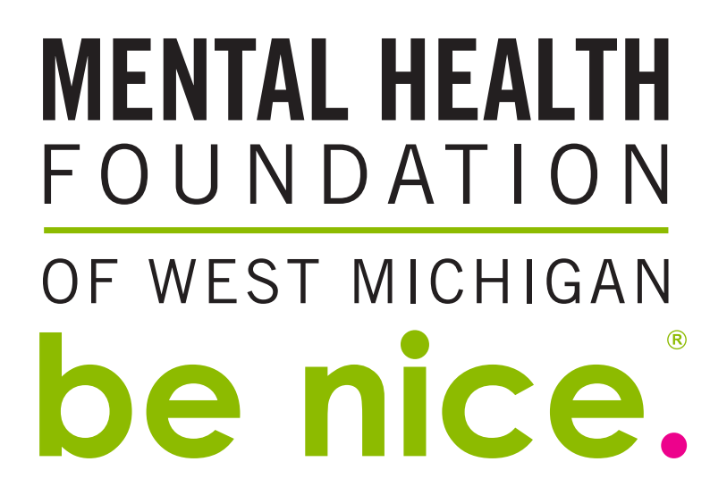
Monthly Checklist
- All school be nice. Activity
- Leadership students attend Board Meeting
- be nice. Kiosk at Rivertown Crossings Mall (runs Nov. 24 – Jan. 3) *great volunteer opportunity for Leadership students

December 2018

September 2017

