MONDAY | TUESDAY | WEDNESDAY | THURSDAY | FRIDAY | SATURDAY | SUNDAY
1 | 2 | 3 | 4  National Mental Illness Awareness Week | 5 | 6 | 7
8 | 9 | 10 | 11 | 12 | 13  NAMI Walk  www.nami.org | 14
15 | 16 | 17 | 18 | 19 | 20 | 21
22 | 23 | 24 | 25 | 26 | 27 | 28
29 | 30 | 31
Monthly Checklist
- Introduce be nice. Action plan to parents
- be nice. Assembly/be nice. Day

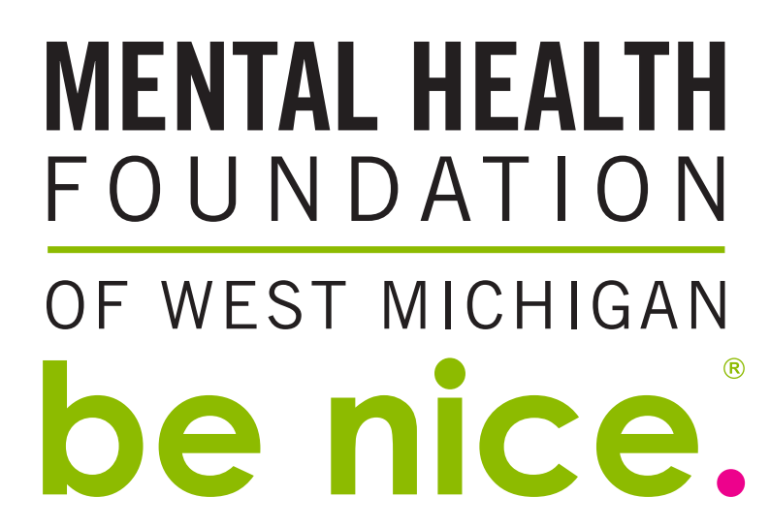
October 2018

September 2017

